The Rapid Application Development (RAD) model is a software development methodology that emphasizes quick prototyping, iterative delivery, and continuous user feedback over rigid planning and long development cycles. It was introduced in the 1980s as a response to the limitations of traditional models like Waterfall, which often delayed user feedback until late in the process.
RAD is particularly useful when speed and flexibility are critical, and when users are available to provide frequent input.
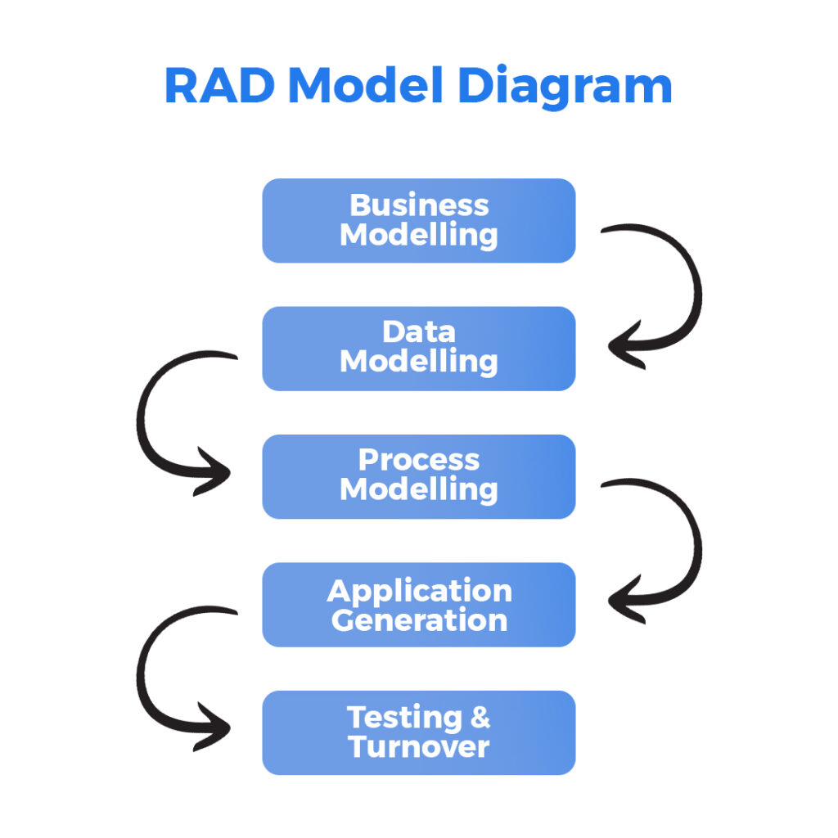
Why RAD model is efficient in SDLC (Software Development Life Cycle ) ?
You can think of RAD as a lean, accelerated version of the SDLC that heavily front-loads user feedback and shifts much of the design and testing into earlier stages. It avoids the long wait times of traditional SDLC models (like Waterfall) and embraces adaptability over rigid documentation.

When to use the RAD Model?
- Well-understood Requirements: When project requirements are stable and transparent, RAD is appropriate.
- Time-sensitive Projects: Suitable for projects that need to be developed and delivered quickly due to tight deadlines.
- Small to Medium-Sized Projects: Better suited for smaller initiatives requiring a controllable number of team members.
- High User Involvement: Fits where ongoing input and interaction from users are essential.
- Innovation and Creativity: Helpful for tasks requiring creative inquiry and innovation.
- Prototyping: It is necessary when developing and improving prototypes is a key component of the development process.
- Low technological Complexity: Suitable for tasks using comparatively straight forward technological specifications.

Key Phases of the RAD Model:
- Requirements Planning
  - Stakeholders, users, and developers meet to discuss and finalize business needs, project scope, and system requirements.
- User Design
  - Through workshops or focus groups, users interact with system prototypes.
  - Feedback is gathered and used to refine the design iteratively.
- Rapid Construction
  - Developers build the actual system using reusable components and automated tools.
  - Frequent iterations and user feedback are incorporated.

- Cutover (Implementation)
  - Final testing, user training, and system deployment.
  - The system goes live and enters the maintenance phase.

Advantages:
- Faster delivery of functional software.
- Encourages user involvement and feedback.
- Flexible to changes in requirements.

Drawbacks of RAD (Rapid Application Development)
- High User Commitment Needed Users must be actively involved throughout the process. If they’re unavailable or unclear, progress stalls or veers off course.
- Scope Creep Risk With flexible and evolving requirements, projects can easily grow beyond the original plan, leading to delays and budget overruns.
- Not Ideal for Large-Scale Systems RAD suits modular or simpler applications. For complex enterprise systems, the lack of rigorous architecture and documentation can hurt scalability and maintainability.
- Heavily Dependent on Skilled Developers Since RAD emphasizes speed and prototyping, it requires experienced and efficient developers to avoid technical debt.

Real-World Example of RAD
- Example: Food Delivery Application Prototype
Imagine a startup wants to launch a food delivery app quickly to test in one city.
- Phase 1: They gather basic requirements—users can browse restaurants and place orders.
- Phase 2–3: Designers and developers rapidly build a working prototype that allows for mock orders.
- Phase 4: They use low-code tools to build a functional beta version.
- Phase 5: Real users test it. Feedback like “Add payment options” or “Live order tracking” is quickly implemented in follow-up iterations.

- Example: Online Banking Application Prototype
Imagine A bank wants to launch a new mobile banking app with features like: Account balance viewing, Fund transfers, Mini-statements, Bill payments .
Phase 1: The product team, developers, and a few customers sit together for a short planning session to define core features.
Phase 2: Developers create quick prototypes of the user interface (e.g., login page, dashboard, fund transfer screen).
Customers test these prototypes and provide feedback.
Phase 3: Developers use component-based development to build small working modules (like fund transfer and balance check).
After each module is built, it’s tested and shown to users for feedback.
Phase 4 : Once major feedback is incorporated and the modules are integrated, the app is tested and deployed to production.
Why RAD Works Here:
- The bank gets a working app quickly and can adapt it based on real user input.
- Customer expectations are aligned with the app from the beginning.
- Iterative testing helps fix bugs before full deployment.

Other Real-Life Examples:
- Startups building MVPs (Minimum Viable Products)
- Internal enterprise tools for HR, CRM, or reporting
- Educational platforms testing new learning modules

Conclusion :
The Rapid Application Development (RAD) model offers a powerful approach to software development, focusing on speed, flexibility, and stakeholder involvement. By enabling quick iterations and the use of reusable components, RAD ensures the fast delivery of functional prototypes, enhancing user satisfaction and project adaptability. However, its reliance on highly skilled developers, modular design, and automated tools presents challenges, particularly for projects with complex requirements or limited resources.

